_______________________________________________________________________

**CSC121 PYTHON Programming**

_______________________________________________________________________

LAB 09 Objects and Their Use

# Objectives

In this lab assignment, students will learn:

- How to use objects in a program

- How to invoke an object’s methods

- How to use Turtle Graphics

- How to use methods of Turtle objects

# Goals

In this lab assignment, students will demonstrate the abilities to:

- use objects in a program

- invoke an object’s methods

- use Turtle Graphics

- use methods of Turtle objects

# Instruction and Problems

Write a Python program for each of the problems in this lab. Please use PyCharm to type and test your programs. Submit the Python files to Blackboard for credit. In this lab, you should submit 4 Python files, one for each problem.

## Problem 1

Write a Python program that uses Turtle Graphics to draw the letter “E” with four lines. Decide the size and the location of the letter yourself. Example:

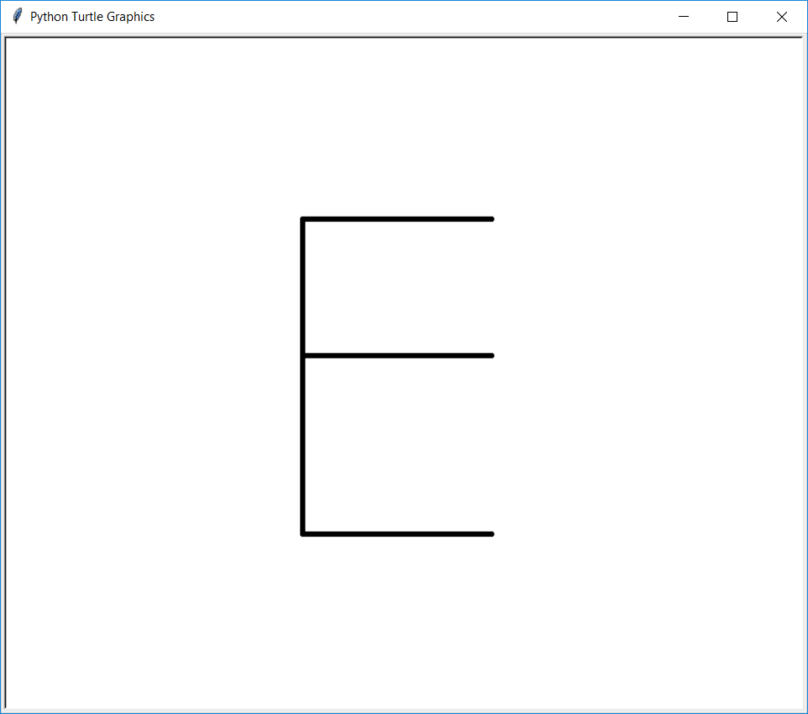

Save your Python program in a file named **Lab09P1.py**.

## Problem 2

Write a Python program that uses Turtle Graphics to draw the letter “M” with four lines. Decide the size and the location of the letter yourself. Example:

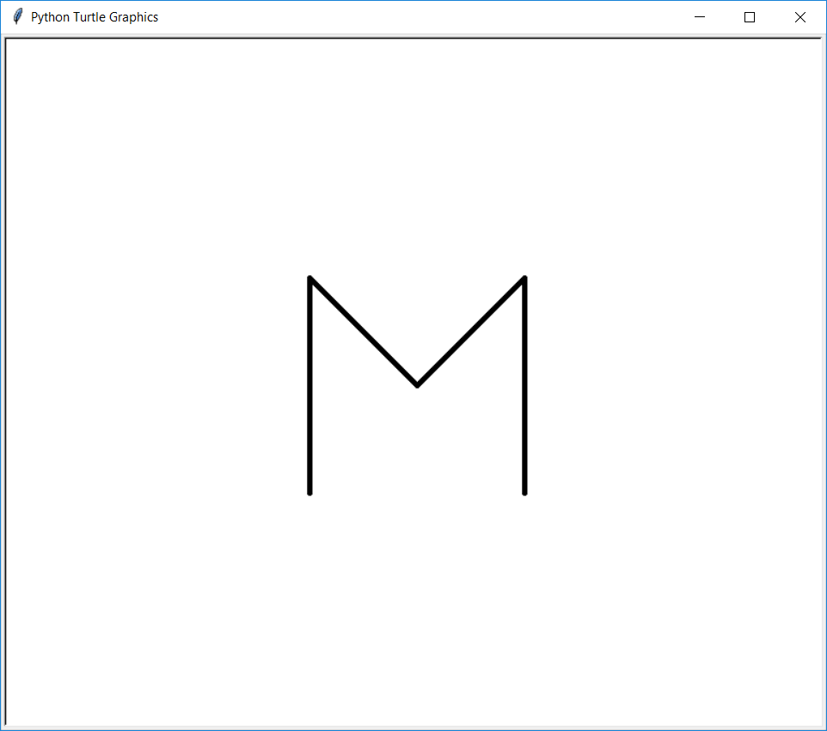

Save your Python program in a file named **Lab09P2.py**.

## Problem 3

Write a Python program that uses Turtle Graphics to draw the letters “XYZ” with straight lines. Decide the size and the location of the letters yourself. Example:

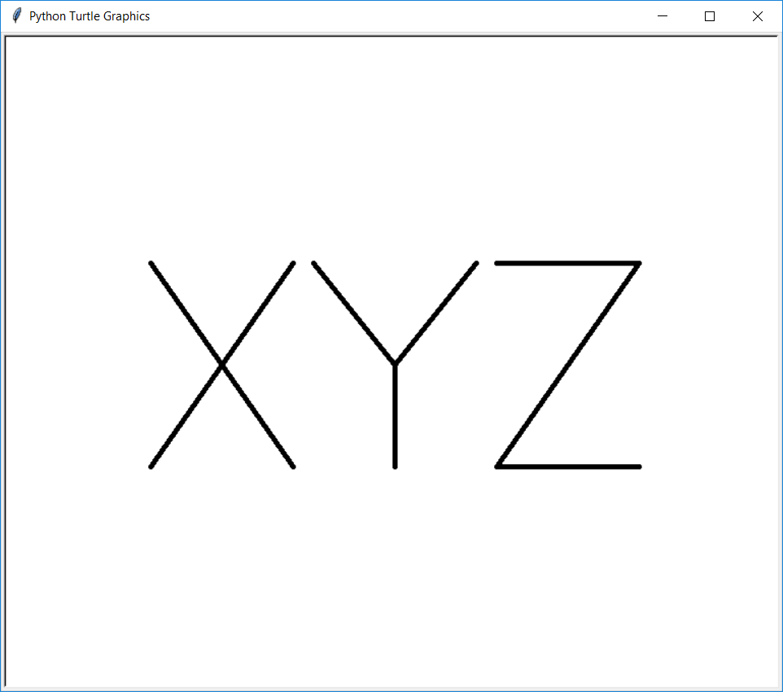

Save your Python program in a file named **Lab09P3.py**.

## Problem 4

Write a Python program that shows a turtle walking back and forth between two vertical walls. Please do the following:

1. Create a 800 X 600 Turtle Graphics window
2. Draw a vertical line at x-coordinate = -300. The y-coordinates of the two end points are 200 and -200, respectively.
3. Draw another vertical line at x-coordinate = 300. The y-coordinates of the two end points are 200 and -200, respectively.
4. Create a turtle object and change the shape from arrowhead to turtle.
5. Use a loop to make the turtle walk 2000 steps. Whenever the turtle hits a wall, it turns 180 degree and continues to walk.

Screenshot of the program:

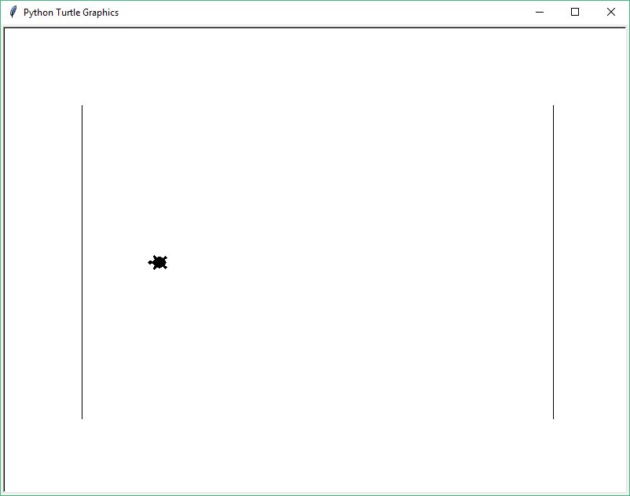

Save your Python program in a file named **Lab09P4.py**.

# Grading rubric for Program 1, 2 and 3

Drawing a letter [12 points]

# Grading rubric for Program 4

Drawing vertical walls [10 points]

Making turtle walk [10 points]

Making turtle turn around when hitting a wall [15 points]

Other statements [5 points]